**Cellular Respiration**

* The remaining energy from cellular respiration is used to form a compound called adenosine triphosphate (ATP).
* ATP is formed when an inorganic phosphate group is joined to a molecule of adenosine diphosphate (ADP).
* Adenosine triphosphate is a high-energy molecule that’s required by cells to create energy for cell function.
* It has one Adenosine atom joined to 3 phosphate atoms.
* Food that’s ingested is broken down into glucose – glucose is used to create ATP.

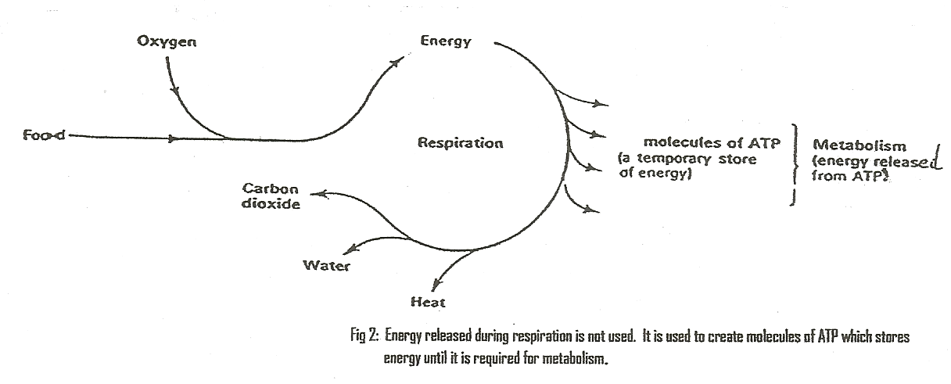

* The ATP molecule consists of adenosine and a chain of 3 phosphate groups.
* The bond between the second and third phosphate is a high-energy bond.
* Food that’s ingested is broken down into glucose which is used to create ATP.



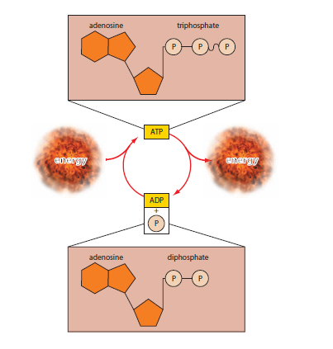

* Removal of the third phosphate group releases the energy in the bond.
* The ADP formed when the energy is released can be reused to store some more of the energy from cellular respiration.
* ATP is a way of transferring energy from cellular respiration to cell processes that utilise energy.
* The building up of ATP is an anabolic process that requires energy.
* The breaking down of ATP to ADP+P is a catabolic process that releases energy.
* The building up of large molecules requires energy to form the chemical bonds – the energy required comes from the breakdown of ATP to ADP+P.

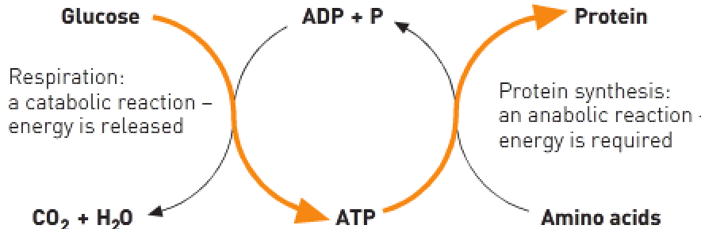

There ae 2 types of respiration:

1. Anaerobic respiration – Occurs in the absence of oxygen.
2. Aerobic respiration – Occurs in the presence of oxygen.

|  |  |  |
| --- | --- | --- |
|  | Aerobic respiration: | Anaerobic respiration: |
| Number of ATP molecules produced from one glucose molecule. | 36 ATP aerobically + 2 ATP anaerobically = 38 ATP. | 2 ATP. |
| Location within the cell. | Mitochondria. | Cytoplasm. |
| Waste products produced. | Carbon dioxide and water. | Pyruvic acid 🡪 lactic acid. |
| Process. | Aerobic glycolysis. | Anaerobic glycolysis. |
| Time taken. | Slower process. | Immediate process. |
| Reactants to produce the products. | Glucose and oxygen. | Glucose. |

Anaerobic respiration:

* Glycolysis: The breaking down of glucose to form ATP molecules.
* In glycolysis a glucose molecule is broken down to 2 molecules of pyruvic acid (no oxygen required).
* If no oxygen is available, the pyruvic acid produced in glycolysis is then converted to lactic acid.
* Lactic acid from anaerobic respiration is taken by blood to the liver where it can recombine with oxygen to form glucose and eventually glycogen.
* Oxygen debt – Occurs when the lactic acid build-up from anaerobic glycolysis isn’t being met with sufficient oxygen. Oxygen is required to remove the lactic acid and take it to the liver to be converted to glucose.

Aerobic respiration:

* Occurs in the mitochondria.
* The pyruvic acid from glycolysis is completely broken down to carbon dioxide and water.

To complete the breakdown of glucose, the 2 pyruvic acid molecules produced in glycolysis must enter a mitochondrion where enzymes are available to allow 2 more series of reactions to occur:

1. Citric acid cycle (Krebs cycle) – Results in the formation of 2 more ATP molecules.
2. Electron transport system – Can produce up to 34 molecules of ATP from the products of one molecule of glucose.

Thus, aerobic respiration of one molecule of glucose has the potential to generate 38 molecules of ATP:

* 2 from glycolysis.
* 2 from the citric acid cycle.
* 34 from the electron transport mechanism.

